**React**

**9. ReactJS-HOL**

**Step 1: Create React Project**

In your terminal (VS Code):

**npx create-react-app PlayertApp**

**cd PlayertApp**

**Step 2: Create Components Folder**

In the src/ folder:

1. Right-click src > New Folder → name it Components
2. Inside Components, create these 3 files:
   * ListofPlayers.js
   * Indian Players.js

**Step 3: Code for Each Component**

**ListofPlayers.js**

import React from 'react';

const ListofPlayers = () => {

const players = [

{ name: "Virat Kohli", score: 85 },

{ name: "Rohit Sharma", score: 45 },

{ name: "KL Rahul", score: 60 },

{ name: "Hardik Pandya", score: 75 },

{ name: "Ravindra Jadeja", score: 40 },

{ name: "Jasprit Bumrah", score: 90 },

{ name: "Shubman Gill", score: 95 },

{ name: "Shreyas Iyer", score: 30 },

{ name: "Mohammed Shami", score: 78 },

{ name: "Rishabh Pant", score: 88 },

{ name: "Axar Patel", score: 55 }

];

// ES6 arrow function to filter players with score < 70

const lowScorers = players.filter(player => player.score < 70);

return (

<div>

<h2>All Players:</h2>

<ul>

{players.map((player, i) => (

<li key={i}>{player.name} - {player.score}</li>

))}

</ul>

<h2>Players with Score below 70:</h2>

<ul>

{lowScorers.map((player, i) => (

<li key={i}>{player.name} - {player.score}</li>

))}

</ul>

</div>

);

};

export default ListofPlayers;

**IndianPlayers.js**

import React from 'react';

const IndianPlayers = () => {

const T20players = ["Virat", "Rohit", "Rahul", "Hardik", "Pant"];

const RanjiPlayers = ["Iyer", "Jadeja", "Gill", "Axar", "Shami"];

// Merge arrays using spread operator

const allPlayers = [...T20players, ...RanjiPlayers];

// Destructure into even and odd indexed players

const oddTeam = allPlayers.filter((_, index) => index % 2 !== 0);

const evenTeam = allPlayers.filter((_, index) => index % 2 === 0);

return (

<div>

<h2>All Merged Players:</h2>

<ul>

{allPlayers.map((name, i) => <li key={i}>{name}</li>)}

</ul>

<h2>Even Index Team:</h2>

<ul>

{evenTeam.map((name, i) => <li key={i}>{name}</li>)}

</ul>

<h2>Odd Index Team:</h2>

<ul>

{oddTeam.map((name, i) => <li key={i}>{name}</li>)}

</ul>

</div>

);

};

export default IndianPlayers;

**Step 4: Modify App.js to Use Components**

In src/App.js, update the code like this:

import React from 'react';

import ListofPlayers from './ListofPlayers';

import IndianPlayers from './IndianPlayers';

function App() {

const flag = true; // toggle this to false to see IndianPlayers

return (

<div className="App">

<h1>Cricket App</h1>

{flag ? <ListofPlayers /> : <IndianPlayers />}

</div>

);

}

export default App;

**Step 5: Start the App**

In your terminal:

**npm start**

Then open your browser and go to:

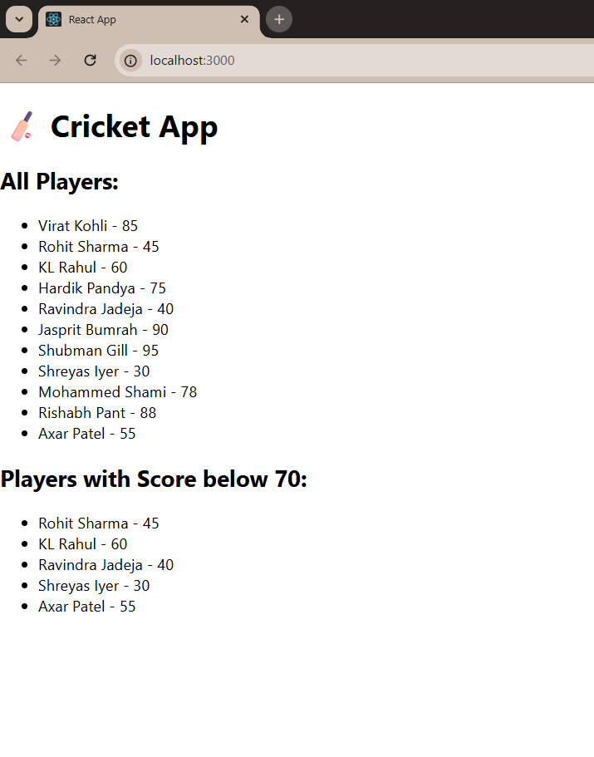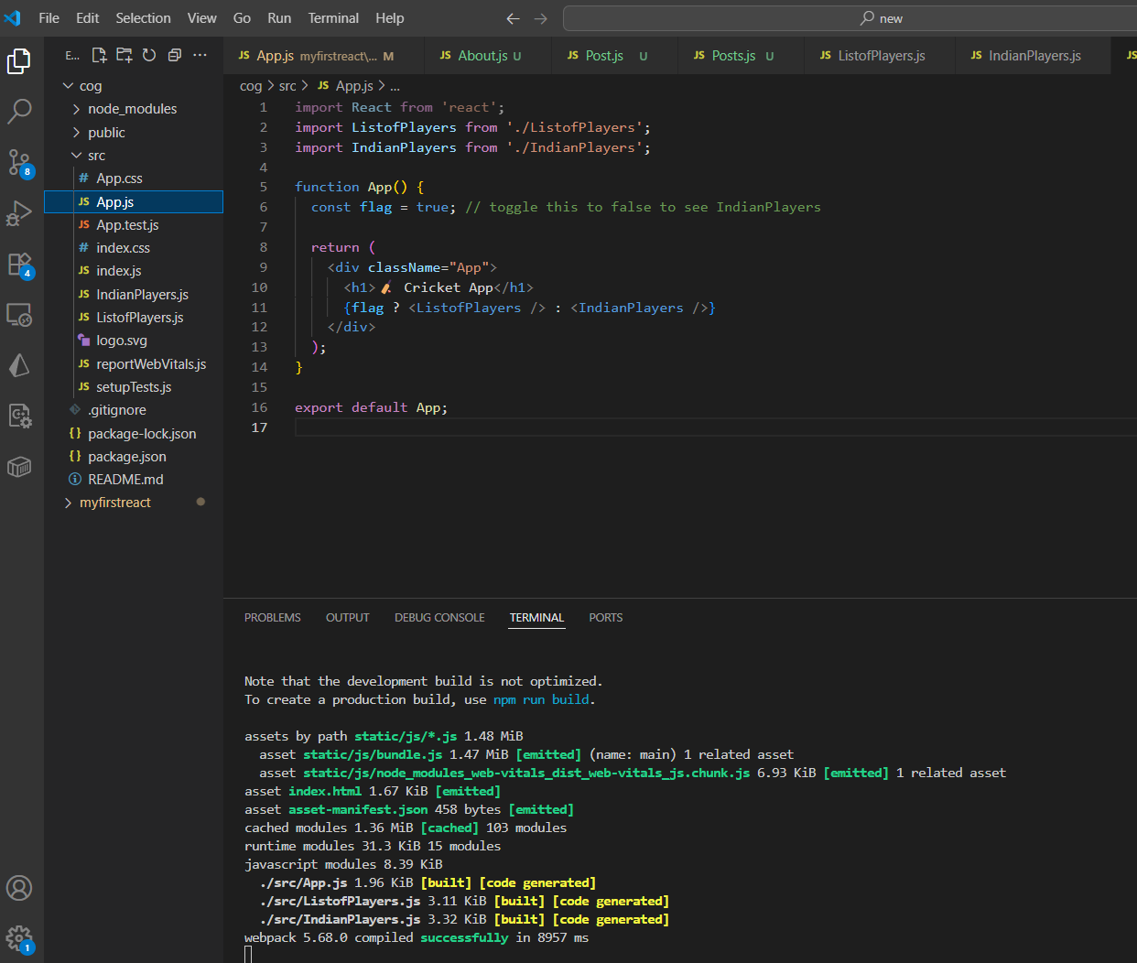**http://localhost:3000**

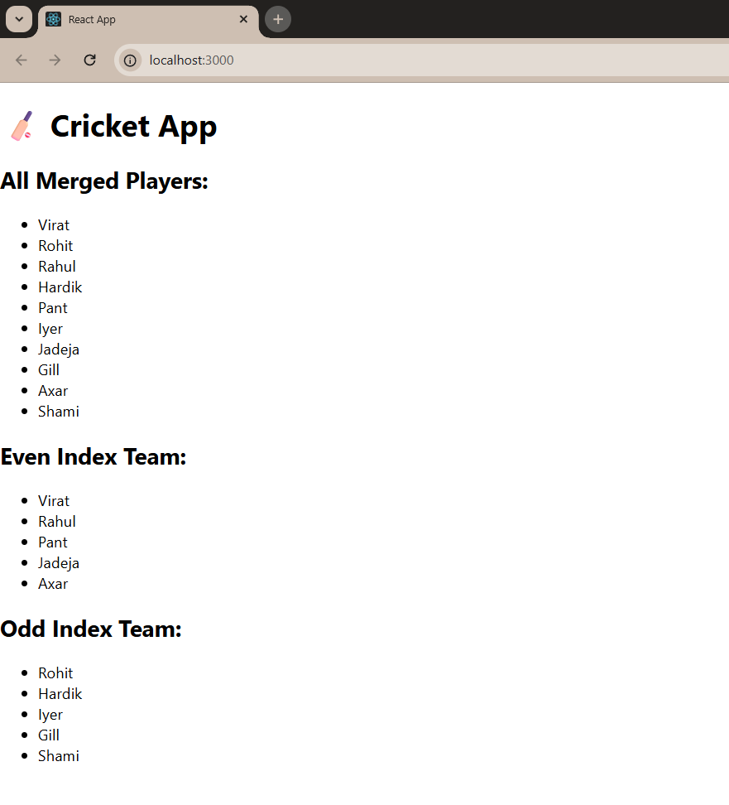

**10. ReactJS-HOL**

**Step 1: Create React Project**

In your terminal (VS Code):

**npx create-react-app officeapp**

**cd officeapp**

**Step 2: Modify App.js and App.css**

In src/App.js, update the code like this:

import React from 'react';

import './App.css';

function App() {

const heading = <h1>🏢 Office Space Rental Listings</h1>;

const imageUrl = "https://via.placeholder.com/600x300?text=Office+Space";

const office = {

name: "Premium Tech Park",

rent: 50000,

address: "Bangalore, India"

};

const officeList = [

{ name: "Eco Tower", rent: 45000, address: "Mumbai" },

{ name: "Skyline Plaza", rent: 72000, address: "Delhi" },

{ name: "Global Hub", rent: 61000, address: "Chennai" },

{ name: "WorkZone", rent: 30000, address: "Hyderabad" },

];

const getRentColor = (rent) => {

return { color: rent < 60000 ? "red" : "green" };

};

return (

<div className="App">

{heading}

<img src={imageUrl} alt="Office Space" style={{ width: '100%', maxHeight: '300px' }} />

<h2>Featured Office</h2>

<p><strong>Name:</strong> {office.name}</p>

<p><strong>Address:</strong> {office.address}</p>

<p><strong>Rent:</strong> <span style={getRentColor(office.rent)}>{office.rent}</span></p>

<h2>Other Office Listings</h2>

{officeList.map((item, index) => (

<div key={index} style={{ border: '1px solid #ccc', margin: '10px', padding: '10px', borderRadius: '8px' }}>

<p><strong>Name:</strong> {item.name}</p>

<p><strong>Address:</strong> {item.address}</p>

<p><strong>Rent:</strong> <span style={getRentColor(item.rent)}>{item.rent}</span></p>

</div>

))}

</div>

);

}

export default App;

**App.css**

.App {

font-family: 'Segoe UI', Tahoma, Geneva, Verdana, sans-serif;

padding: 20px;

background-color: #f9f9f9;

}

h1, h2 {

color: #333;

}

**Step 5: Start the App**

In your terminal:

**npm start**

Then open your browser and go to:  
**http://localhost:3000**

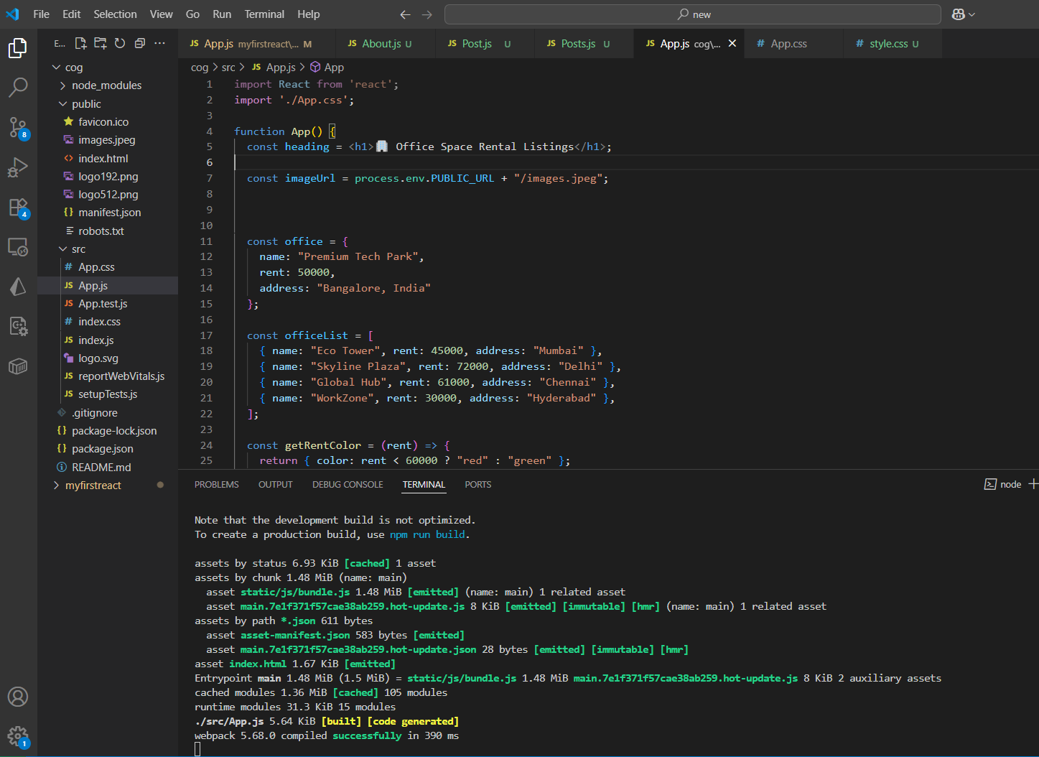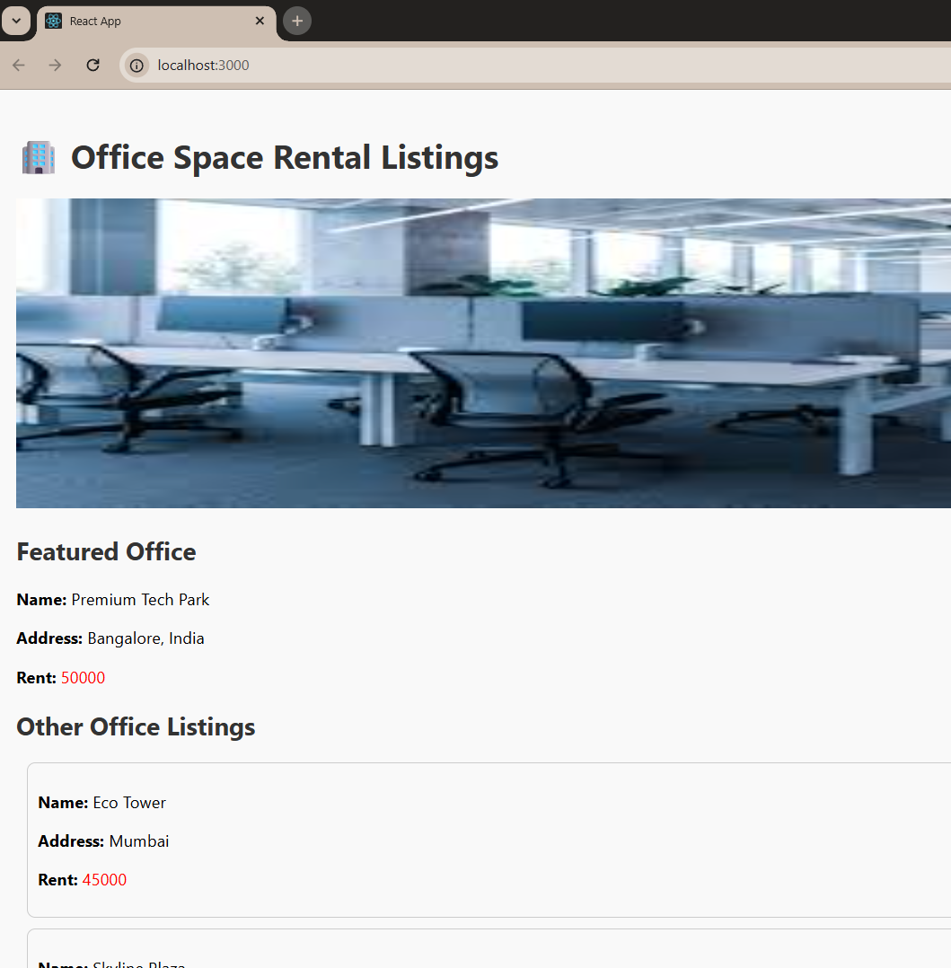

**11. ReactJS-HOL**

**Step 1: Create React Project**

In your terminal (VS Code):

**npx create-react-app eventApp**

**cd eventApp**

**Step 2: Create Components Folder**

In the src/ folder:

1. Right-click src > New Folder → name it Components
2. Inside Components, create these 1 files:
   * CurrencyConvertor.js

**Step 3: Code for Each Component**

**CurrencyConvertor.js**

import React, { useState } from 'react';

const CurrencyConvertor = () => {

const [rupees, setRupees] = useState('');

const [euro, setEuro] = useState('');

const handleSubmit = (e) => {

e.preventDefault();

const converted = parseFloat(rupees) / 89.5; // Example conversion rate

setEuro(converted.toFixed(2));

};

return (

<div>

<h2>Currency Converter (INR to Euro)</h2>

<form onSubmit={handleSubmit}>

<input

type="number"

placeholder="Enter amount in INR"

value={rupees}

onChange={(e) => setRupees(e.target.value)}

/>

<button type="submit">Convert</button>

</form>

{euro && <p>€ {euro}</p>}

</div>

);

};

export default CurrencyConvertor;

**Step 4: Modify App.js to Use Components**

In src/App.js, update the code like this:

import React, { Component } from 'react';

import CurrencyConvertor from './CurrencyConvertor';

class App extends Component {

constructor(props) {

super(props);

this.state = {

counter: 0,

};

}

increment = () => {

this.setState({ counter: this.state.counter + 1 });

this.sayHello();

};

sayHello = () => {

alert('Hello! This is a static message.');

};

decrement = () => {

this.setState({ counter: this.state.counter - 1 });

};

sayWelcome = (msg) => {

alert(msg);

};

handleClick = (e) => {

e.preventDefault(); // Synthetic Event

alert('I was clicked');

};

render() {

return (

<div className="App" style={{ padding: 20 }}>

<h1>React Events Example</h1>

<h2>Counter: {this.state.counter}</h2>

<button onClick={this.increment}>Increment</button>

<button onClick={this.decrement}>Decrement</button>

<hr />

<button onClick={() => this.sayWelcome("Welcome to React!")}>Say Welcome</button>

<hr />

<button onClick={this.handleClick}>Synthetic Event OnPress</button>

<hr />

<CurrencyConvertor />

</div>

);

}

}

export default App;

**Step 5: Start the App**

In your terminal:

**npm start**

Then open your browser and go to:

**http://localhost:3000**

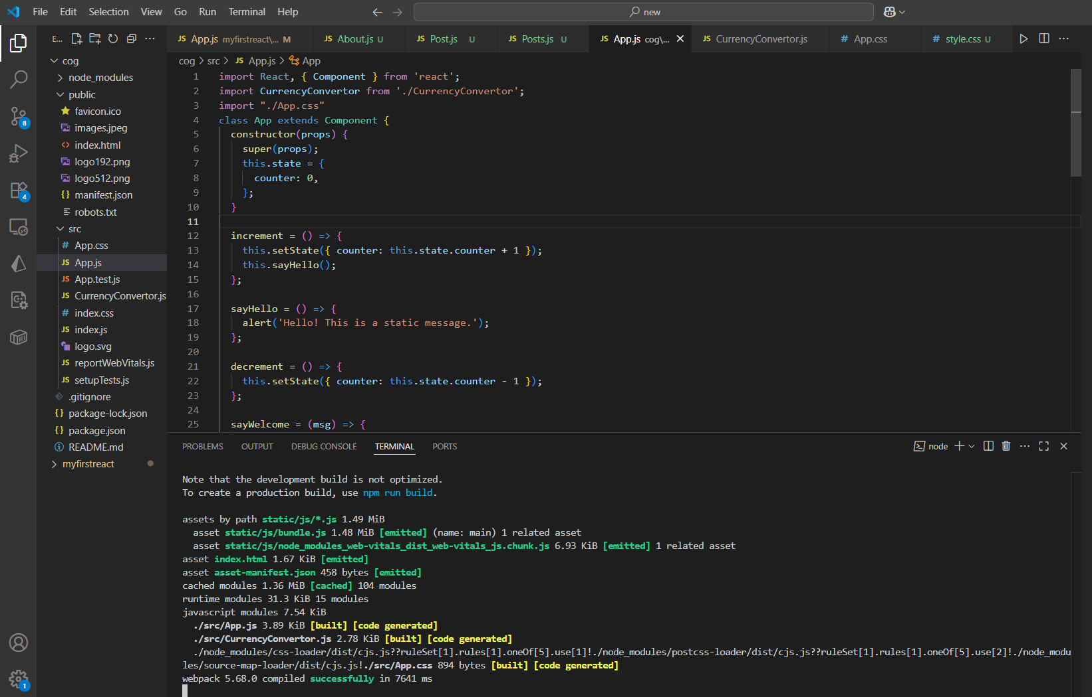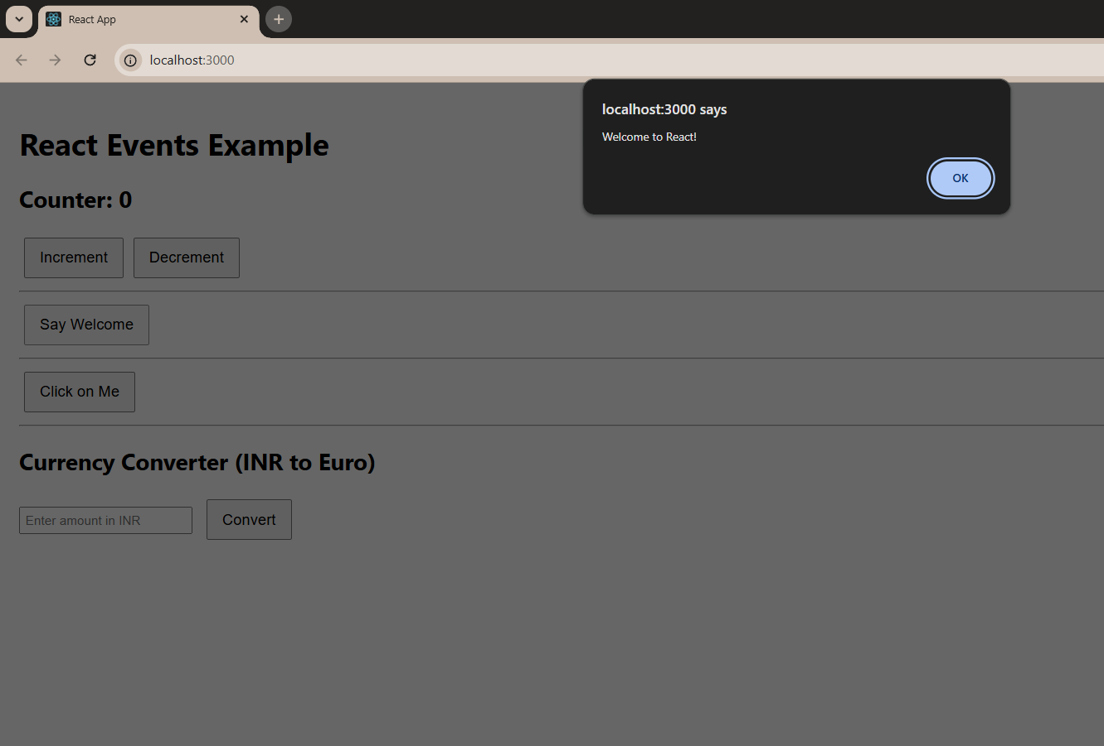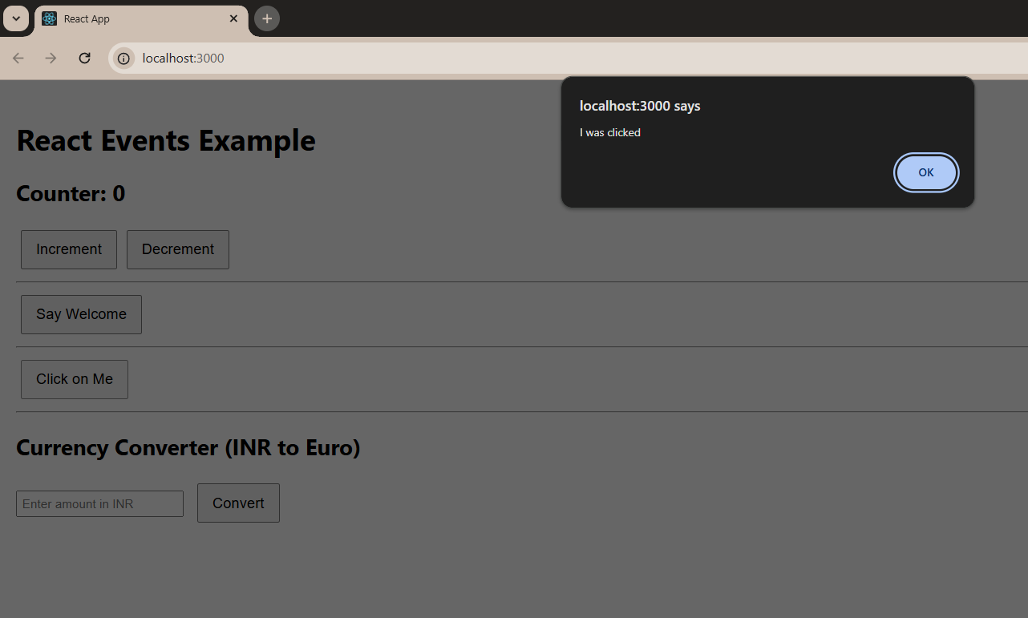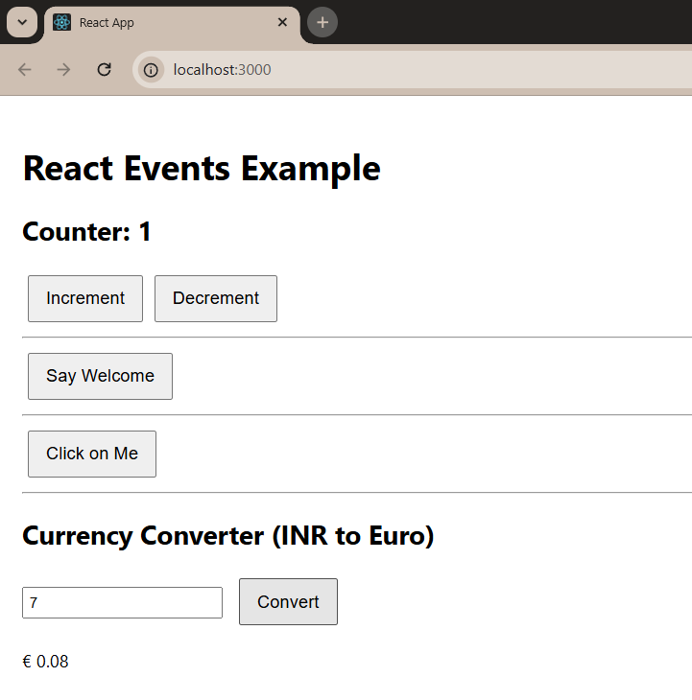

**12. ReactJS-HOL**

**Step 1: Create React Project**

In your terminal (VS Code):

**npx create-react-app TicketApp**

**cd TicketApp**

**Step 2: Create Components Folder**

In the src/ folder:

1. Right-click src > New Folder → name it Components
2. Inside Components, create these 2 files:
   * GuestPage.js
   * UserPage.js

**Step 3: Code for Each Component**

**GuestPage.js**

import React from 'react';

const GuestPage = () => {

return (

<div>

<h2>Welcome Guest!</h2>

<p>Here are the available flight details:</p>

<ul>

<li>✈️ Delhi to Mumbai - ₹4500</li>

<li>✈️ Bangalore to Chennai - ₹3200</li>

<li>✈️ Hyderabad to Pune - ₹4100</li>

</ul>

</div>

);

};

export default GuestPage;

**UserPage.js**

import React from 'react';

const UserPage = () => {

return (

<div>

<h2>Welcome Back, User!</h2>

<p>You can now book your tickets:</p>

<button>Book Delhi to Mumbai</button>

<button>Book Bangalore to Chennai</button>

<button>Book Hyderabad to Pune</button>

</div>

);

};

export default UserPage;

**Step 4: Modify App.js and App.css**

In src/App.js, update the code like this:

import React, { useState } from 'react';

import GuestPage from './GuestPage';

import UserPage from './UserPage';

import './App.css';

function App() {

const [isLoggedIn, setIsLoggedIn] = useState(false);

const loginHandler = () => setIsLoggedIn(true);

const logoutHandler = () => setIsLoggedIn(false);

let pageContent;

if (isLoggedIn) {

pageContent = <UserPage />;

} else {

pageContent = <GuestPage />;

}

return (

<div className="App">

<h1>🛫 Ticket Booking App</h1>

<div style={{ marginBottom: '20px' }}>

{isLoggedIn ? (

<button onClick={logoutHandler}>Logout</button>

) : (

<button onClick={loginHandler}>Login</button>

)}

</div>

{pageContent}

</div>

);

}

export default App;

**App.css**

.App {

font-family: Arial, sans-serif;

text-align: center;

padding: 30px;

}

button {

padding: 10px 15px;

margin: 5px;

font-size: 16px;

}

**Step 5: Start the App**

In your terminal:

**npm start**

Then open your browser and go to:  
  
**http://localhost:3000**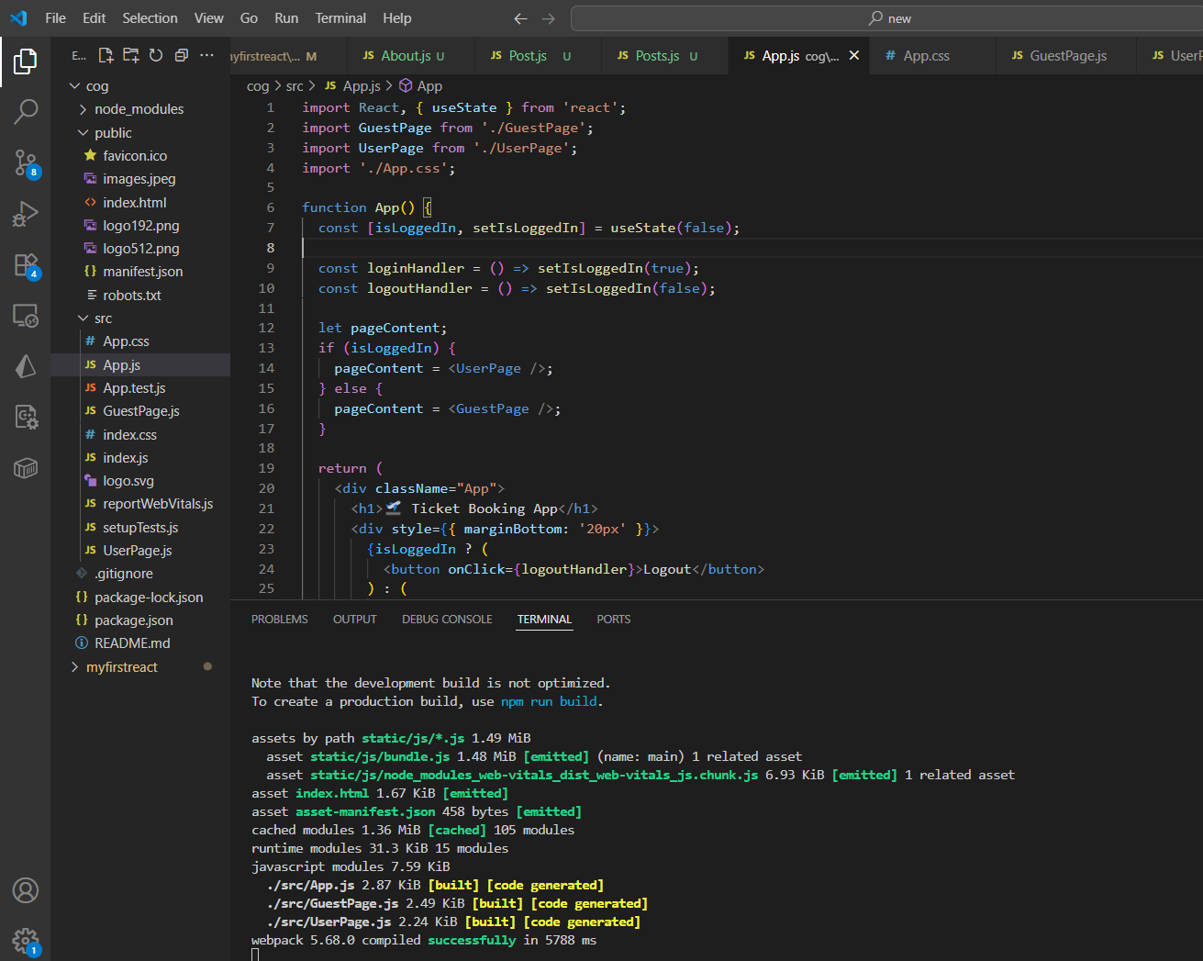

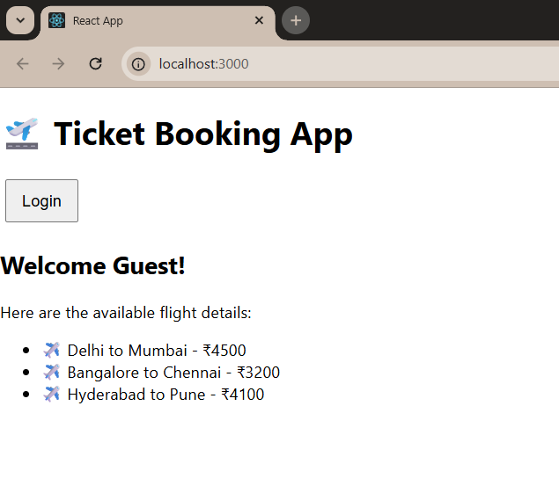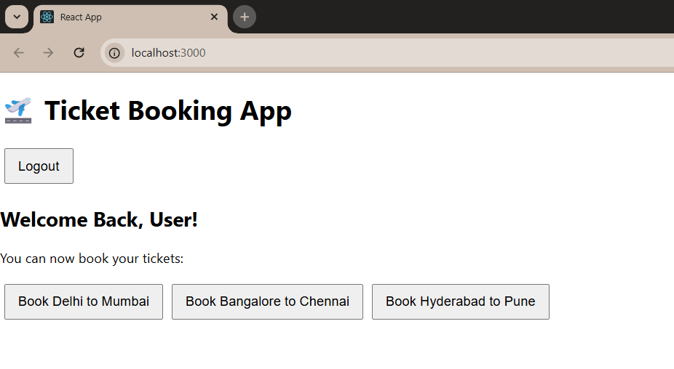

**13. ReactJS-HOL**

**Step 1: Create React Project**

In your terminal (VS Code):

**npx create-react-app BlogApp**

**cd BlogApp**

**Step 2: Create Components Folder**

In the src/ folder:

1. Right-click src > New Folder → name it Components
2. Inside Components, create these 3 files:
   * BookDetails.js
   * BlodDetails.js
   * CourseDetails.js

**Step 3: Code for Each Component**

**BookDetails.js**

import React from 'react';

const BookDetails = () => {

const books = [

{ id: 1, title: 'React Mastery', author: 'Dan Abramov' },

{ id: 2, title: 'JavaScript Essentials', author: 'Kyle Simpson' }

];

return (

<div>

<h2>📚 Book Details</h2>

<ul>

{books.map(book => (

<li key={book.id}>

<strong>{book.title}</strong> by {book.author}

</li>

))}

</ul>

</div>

);

};

export default BookDetails;

**BlogDetails.js**

import React from 'react';

const BlogDetails = () => {

const blogs = [

{ id: 1, title: 'Learning React in 2025' },

{ id: 2, title: 'The Rise of TypeScript' }

];

return (

<div>

<h2> Blog Posts</h2>

<ul>

{blogs.map(blog => (

<li key={blog.id}>{blog.title}</li>

))}

</ul>

</div>

);

};

export default BlogDetails;

**CourseDetails.js**

import React from 'react';

const CourseDetails = () => {

const courses = [

{ id: 1, name: 'Frontend Basics' },

{ id: 2, name: 'Advanced React' }

];

return (

<div>

<h2> Course Details</h2>

<ul>

{courses.map(course => (

<li key={course.id}>{course.name}</li>

))}

</ul>

</div>

);

};

export default CourseDetails;

**Step 4: Modify App.js to Use Components**

In src/App.js, update the code like this:

import React, { useState } from 'react';

import BookDetails from './BookDetails';

import BlogDetails from './BlogDetails';

import CourseDetails from './CourseDetails';

import './App.css';

function App() {

const [selected, setSelected] = useState('books');

// Method 1: if-else

let component;

if (selected === 'books') {

component = <BookDetails />;

} else if (selected === 'blogs') {

component = <BlogDetails />;

} else {

component = <CourseDetails />;

}

return (

<div className="App">

<h1>Blogger App</h1>

<div>

<button onClick={() => setSelected('books')}>Books</button>

<button onClick={() => setSelected('blogs')}>Blogs</button>

<button onClick={() => setSelected('courses')}>Courses</button>

</div>

<hr />

{/* Method 2: element variable (above) */}

{component}

{/* Method 3: Ternary Operator */}

{/*

selected === 'books' ? <BookDetails /> :

selected === 'blogs' ? <BlogDetails /> :

<CourseDetails />

*/}

{/* Method 4: Logical && (not used here directly) */}

{/* {selected === 'books' && <BookDetails />} */}

</div>

);

}

export default App;

**Step 5: Start the App**

In your terminal:

**npm start**

Then open your browser and go to:  
  
http://localhost:3000

